
“
“
Twelve weekly online wellbeing sessions helped African and Caribbean elders to share worries, information and laughter during lockdown (Feb – May 2021).
- Ten to 12 participants met regularly - supported by a facilitator and three volunteers
- Older people were helped to use and benefit from technology
- Online peer support helped reduce anxiety and fear
All participants were Black and older, so had an increased risk of Covid-19. Many also have diabetes.

Creating connection for at-risk, isolated older people
at-risk, isolated older people

Marginal Gains Kirklees:
Connect for Wellbeing (Oasis Care Support Services)
“Connect Group”
You have no idea how much
those sessions helped me
mentally and emotionally

Feedback –Service Users
All 12 group members said their health and wellbeing had improved. Nine people reported a significant shift.
- “The Oasis Connect sessions were
a lifeline for me.”
- “It was good to see one another’s face, not just a telephone call, behind doors and distant.”
- “These sessions are a gift that came at the point in my life when I very much felt like giving up.”
- “The sessions took my mind off the stuff I am going through - I give very many thanks for the guardian angels who came at the right moment….”
- “Technology has really taken us to the limit”
What we have achieved
A time and space for isolated, worried people to connect and improve their wellbeing
Many people had not seen each other for almost a year (since the March 2020 lockdown). They were able to get reacquainted and share experiences.
IT support (and equipment) provided to create online connection
We supported participants to help them to use software and hardware. A local community social enterprise* (and Marginal Gains partner organisation) provided tablets to make online connection possible for some of the participants.
Peer support and learning that had an immediate impact on wellbeing
A facilitator helped the group to discuss their journey through lockdown. Topics included the impact of fear on daily life, and the vaccine. Feedback showed that participants valued being able to learn from each other about how to cope.
Nine members of the group reported a significant shift in their health and wellbeing. These participants hadn’t been out since before the first lockdown and the isolation had made them feel extremely low.

And Bingo too
A weekly dose of Bingo helped the sessions to succeed.
*Local Services 2 You

Feedback – Partners
We know of the great work Oasis Care do in our community, so when TSL got in touch to see if we might be able to help with tablets we were very happy to do so.

We checked what they needed the tablets for, bought them with some Lottery funding we had received and got our IT support person to go down and set things up to make sure they worked OK. We were delighted to be able to support this project.

Andy Petrie
Chief Executive, Local Service 2 You

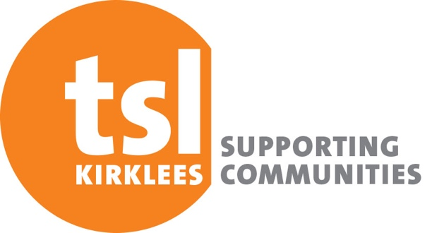
Learning points
- Technology doesn’t have to be barrier for older people if they get the right support.
- Rooted and trusted community organisations can meet specific health and support needs well. In this case creating a rich, accessible social opportunity for isolated and vulnerable older people with a shared cultural heritage.

Oasis Care Support Services is a social enterprise based at St John’s Resource Centre, a community centre in Birkby, Huddersfield.

What was most useful?
- “Feeling connected and back to normal”.
- “Getting back together again”.
- “Being in touch and connected”
- Lots of laughter and fun which really lifted my spirit”.
The group invited members of a diabetes support group to participate in sessions and share information (six participants have diabetes). Type 2 diabetes is two to four times more likely in people of African-Caribbean or Black African descent.

This is one of six Marginal Gains case studies.

Third Sector Leaders Kirklees took an asset-based approach to community-centred health and wellbeing. We supported established organisations to create new offers and activities for marginalised people. These included online social support, growing projects, learning and cultural exchange.

We’ve also summarised five key factors that emerged from this programme in a separate overview.

What’s next?
The sessions will continue online until the group can meet face to face again.

