Reaching out to local marginalised communities

Marginal Gains Projects
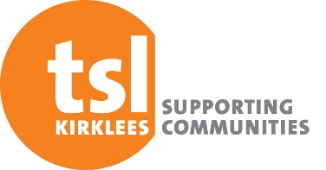
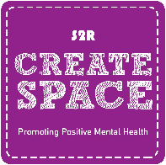
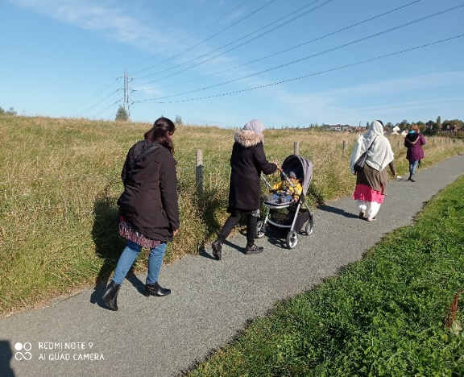
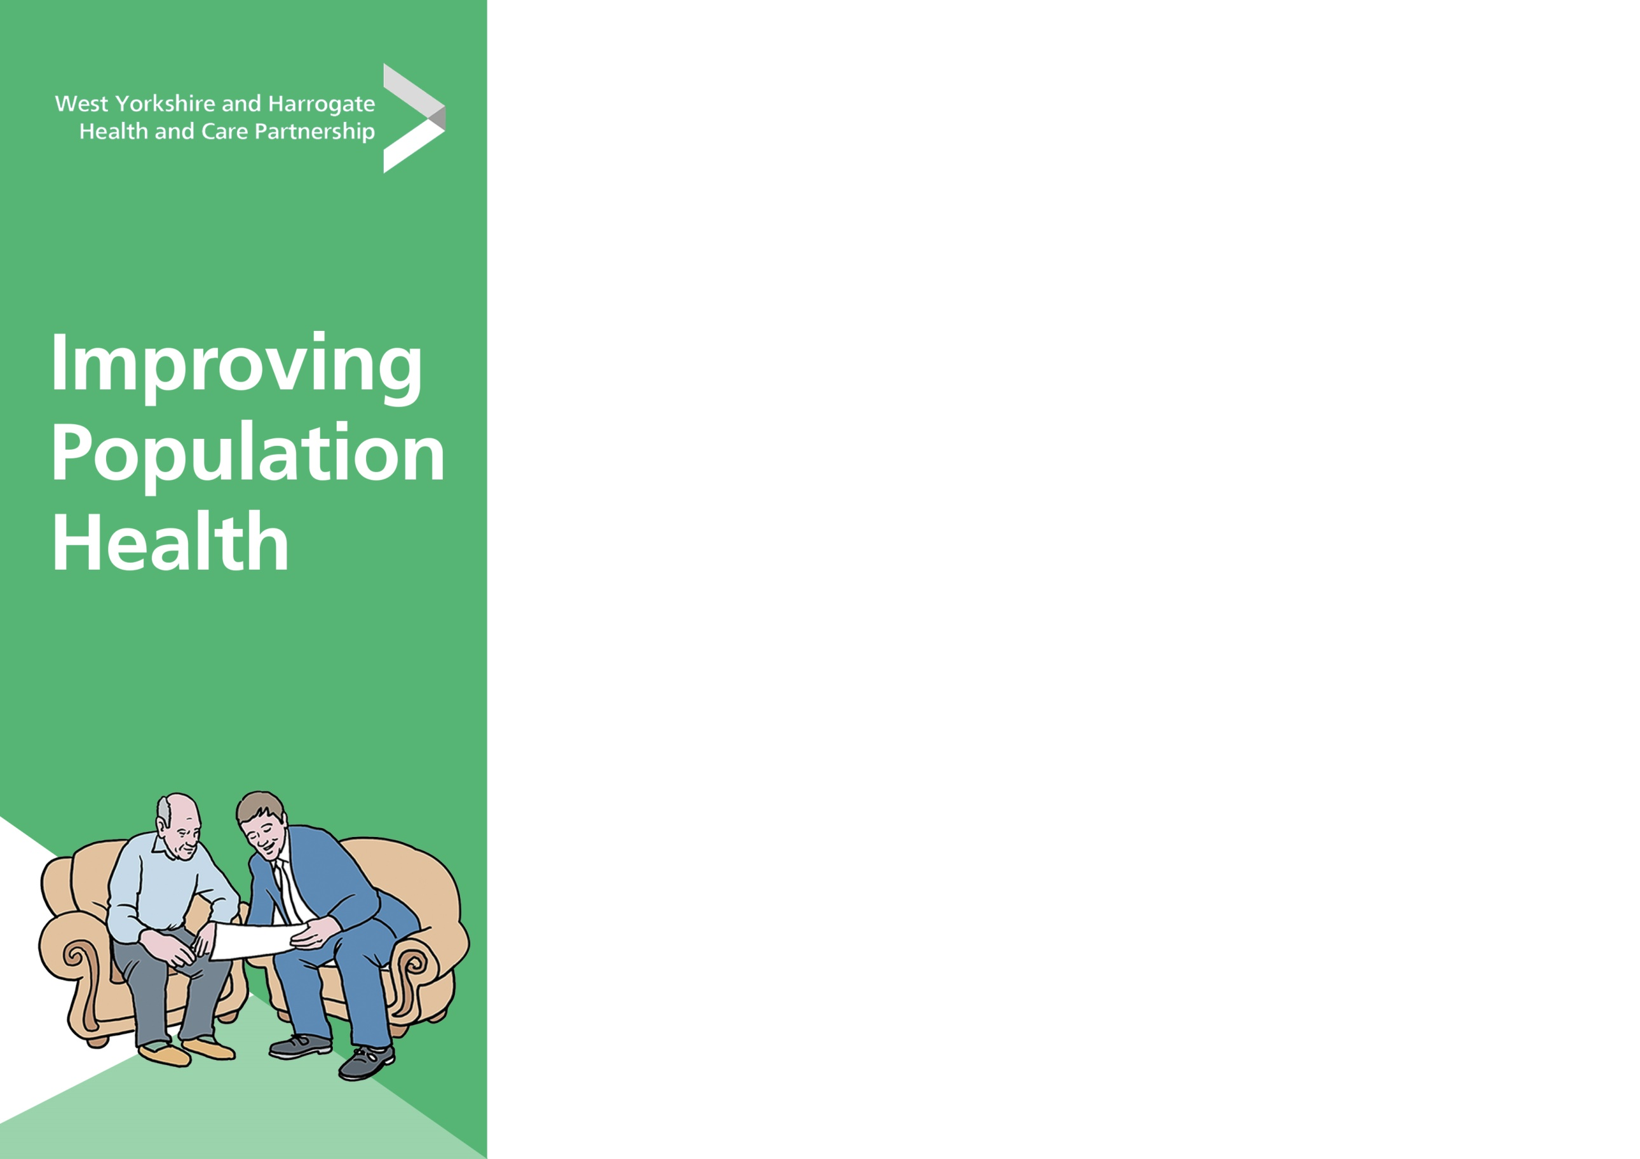
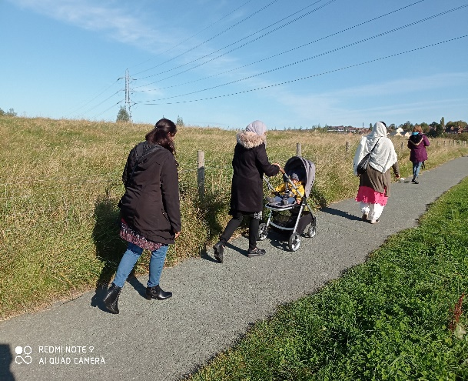
A weekly women’s walking group in Ravensthorpe, brought isolated women together, increased their fitness and enjoyment of the outdoors.

“I wouldn’t have gone for a walk unless I had booked to come on the session, and was really pleased that I had had time out for myself, instead of looking at the laptop”
Due to the covid pandemic situation, S2R designed a diverse range of online and meet up health and wellbeing activities, that local marginalised communities could assess and take part in. Working in partnership with TSL we recognised that we had to meet this challenge head-on and be proactive with service delivery. These varied activities were designed for people of all ages and abilities and included:
- Online Aromatherapy and yoga courses for local visual impairment support group.
- A BAME women’s walking group in Ravensthorpe.
- A collection of videoed walks for people to try later or for those shielding / isolating to enjoy virtually.
- With the local residents and volunteers we helped plant over 10,000 trees at Dewsbury Country Park.
- We delivered a range of interactive online workshops and videos, focussing on ways to remain well, focused on health messages and connectivity during pre-and post-covid lockdown periods.
- We posted or delivered over 800 wellbeing packs and delivered 200 to local community centres with local information and activities included.
- We reached out to communities through online resources, with free workshops, health wellbeing support, relaxation techniques and linking with local & national events such as #Healthy Hydration, Smoking Cessation Support & Mental Health Awareness Week.

Feedback –Service Users
- “I find life hard in the UK. My husband came to the UK twelve years ago, I joined him later, four years ago. I am a teacher very much and feels isolated in a busy England. I have two young boys and am learning English. I have a few local Afghanistan friends in Ravensthorpe of Farsi, and left behind my family home of parents, grandparents, and other family, all living together. I miss my family. I want to meet new friends near to where I live”
- “I have just received my Well Connected Magazine, it’s absolutely brilliant & can I say a big thankyou to all involved in the monthly wellbeing activities I have received during lockdown, it was very much appreciated and helpful”

Feedback –Service Users
- “I find life hard in the UK. My husband came to the UK twelve years ago, I joined him later, four years ago. I am a teacher very much and feels isolated in a busy England. I have two young boys and am learning English. I have a few local Afghanistan friends in Ravensthorpe of Farsi, and left behind my family home of parents, grandparents, and other family, all living together. I miss my family. I want to meet new friends near to where I live”
- “I have just received my Well Connected Magazine, it’s absolutely brilliant & can I say a big thankyou to all involved in the monthly wellbeing activities I have received during lockdown, it was very much appreciated and helpful”
Feedback – Partners
- “Many thanks to all of you for your support in running these sessions. Our members have really benefitted from the activity and it’s made a big difference to their health and wellbeing during this difficult time!”

What we have achieved
We have widened the horizons of opportunity for some – Participants were given the opportunity to take a Walks Leader Training course.
We have helped to improve fitness and health, and how it is perceived - A participant who suffers with many physical ailments, reported to the Community Centre worker, that her physical health is feeling improved.
After the yoga course for people with vision impairment, attendees scored themselves as improved in physical health, confidence, learning abilities, feeling connected and more able to help others.
We produced Health & Wellbeing packs and delivered over 800 to local centres, posted out to individual households and presented online.
Health Inequalities - Well Connected Guide_.pdf

- “We have found our partnership with S2R to be really valuable and to have been able to offer a variety of activities which we wouldn’t have been able to do ourselves has been great!”
Claire Drake, Volunteer and Events Co-ordinator, KVIN (Kirklees Visual Impairment Network)
- I counted 25 attendees - but that was before I started the class, couldn't keep up after that.
Audrey Erbany – Project Art Facilitator

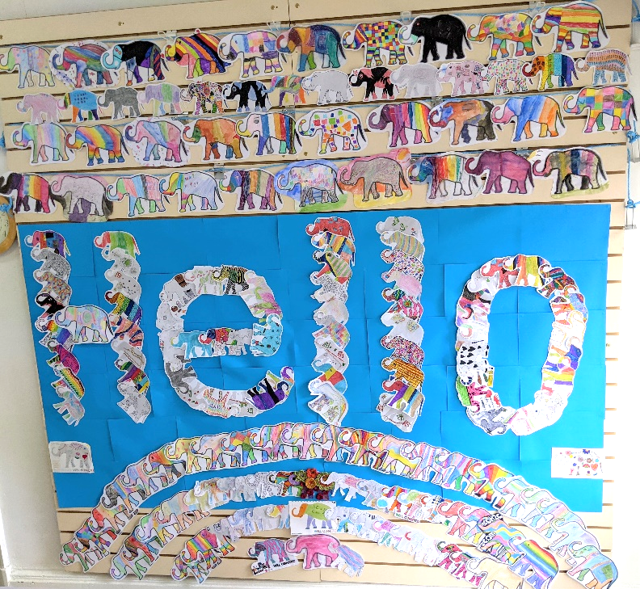
Overall Reflections and Recommendations
- Due to the nature of attendee client bases – some visually impaired, others internet/IT limited - online course feedback has been difficult to obtain.
- People who are aware of our services had more confidence to try new sessions and we still had to work hard to reach marginalised audiences as digital connectivity was an issue for some.
- Our staff team have had to find new ways to communicate every detail of every plan effectively, both to staff and potential attendees without becoming swamped or confused, particularly during short notice changes to Government guidance / policies.
- Providing a service from home has its benefits and limitations, some people lack focus or forget date/times, some dislike appearing on screen and worry its being recorded or uploaded, others crave face to face services.
- People have needed to feel engaged to remain well and healthy during Government lockdowns and that they have a goal or purpose, some needed more support and guidance to achieve this as many are wary of the unknown, change and the future.

This is one of six Marginal Gains case studies.

Third Sector Leaders Kirklees took an asset-based approach to community-centred health and wellbeing. We supported established organisations to create new offers and activities for marginalised people. These included online social support, growing projects, learning and cultural exchange.

We’ve also summarised five key factors that emerged from this programme in a separate overview.

Learning points
1. Clarity is important
2. Options to suit everyone needed
3. Forward planning helps with promotion
4. Great community networking generates local cohesion
What’s next?
- Create more new and interesting activity sessions.
- Continue to react quickly to Government guidance to continue safe on-going activities.
- Continue working with local groups & finding new partnerships.
- Guide & support our attendees through the next stages of the road map and beyond the restriction phase.
Installation of Elephants at S2R Create Space, created by recipients of the Well Connected Guide.
Creating partnerships to reduce health inequalities

June 2021

