

Mapping of third sector organisations in Kirklees which work with people with mental health issues, physical disabilities, learning disabilities and autism

August 2021

Funded by


- BACKGROUND
South West Yorkshire Foundation Trust (SWYFT) recognises that the voluntary and community sectors (VCS) provide the essential infrastructure of services and support for people’s mental health and well-being in each of the local areas served by the Trust, including Kirklees. It acknowledged that the continuation of these groups was essential to maintain current capacity and support people using SWYFT services.
- PURPOSE OF PROJECT DELIVERED IN KIRKLEES

The project would have three aims:
- To collate information to share, subject to consent, on services in Kirklees VCS sector supporting mental health, learning disability and autism. Third Sector Leaders (TSL) also chose to map groups supporting people with disabilities in Kirklees
- To identify the support these group require to sustain their services at such a time when many VCS organisations are experiencing the impact of Covid and limited funding
- To identify VCS group in Kirklees which may require additional resources to support using digital means to reach its communities

- DESIRED OUTCOMES
Through the mapping exercise, TSL Kirklees will help SWYFT identify VCS partners supporting Trust core services; this work would ensure the Trust can work closely with those partners as assets in local communities to:
- Develop relationships to further support community involvement
- Work in partnership with organisations to support the work to address inequalities in each place
- To identify future service providers that could be identified to support sub-contracting arrangements
- Support sustainability of partners with equal benefit for service users, carers and families

- METHODOLOGY
A standard questionnaire was widely distributed to 200 groups in Kirklees which TSL understood to deliver/have delivered services supporting the target groups identified in (2) above. The questionnaire was promoted through:
- TSL members
- Contacts known to TSL staff including Council, health partners, housing and youth networks
- Anchor organisations
- Other Kirklees organisations
- Local websites
Groups were offered the option to email questionnaires back or undertake a telephone interview with the TSL project worker undertaking the mapping exercise. Sixty-three organisations completed the survey, a response rate of 32%. Thirty-two groups chose the telephone interview method. Only one group did not want to share its contact details with SWYFT as it works nationally and did not want to engage in local networks.

5. FINDINGS
Questions 1 to 4 captured contact details of groups, attached at Appendix 1 in a spreadsheet; these groups agreed that SWYFT their details could be shared with the Trust. (Most groups answered all questions in the survey; however some did not, therefore some figures in diagrams do not always total 63, the number of groups which completed the survey.)
One group did not give consent. Responses to further questions are summarised below.

Question 5 - What does your organisation aim to achieve?
Groups responding confirmed their aims were:
To support stroke survivors
To provide enjoyable and therapeutic activities for groups of disabled people
Support and therapy for people seeking asylum in Kirklees and refugees
Support for children and families who have life limiting conditions
Supporting adults with learning disabilities
Providing affordable childcare
Develop IT skills and knowledge
Providing occupational therapy
Enable people who live with HIV live positive lives, free of stigma
Improving the quality of life of local people – a few groups focused on specific geographical areas of Almondbury, Lindley, Thornton Lodge, north Huddersfield, Ravensthorpe & Savile Town
Provide emotional support for carers of people with mental health needs
Self-advocacy
Support people to manage their mental health and prevent them from requiring hospital admission
Housing support and help people live independently in the community
Build self esteem and coping skills
Supporting aspiring actors with learning disabilities work in performing arts
Help people with disabilities access the countryside
Reduce reoffending
Activities outside for people with physical, learning disabilities, autism and mental health conditions
Building resilience and skills of young people
Provide social opportunities for people with disabilities
Provide wide range of activities from breakfast clubs to sporting memory sessions for the elderly
Support survivors of trauma, rape and sexual violence
Support people with sight loss maintain independence
Provide affordable counselling
Provide quality, affordable professional home care
Relationship counselling for couples, individuals, families and young people
Support to anyone affected by the death of a baby
Provision of business consultancy and training to the VCS
Support community activities through an Asian business network
Provide world dance sessions to improve well being
Cycling and exercise skills in a safe environment
Support for people with poor emotional and mental health issues
Tackling social isolation
Provide dance and exercise for people with special needs, disabilities and the elderly
Support for adults who stammer
Provide access to affordable food clubs
Encourage community led activities and support to the most excluded in society
Support for young parents under 24
Support victims of domestic abuse
Support individuals affected by or living with a brain tumour
Provision of yoga sessions for people with additional needs
Connect communities through community transport
Community support, advice services along with accessible community space and community cafe

Question 6 - Who do you provide services for: people with learning/physical disabilities, mental health issues or autism?
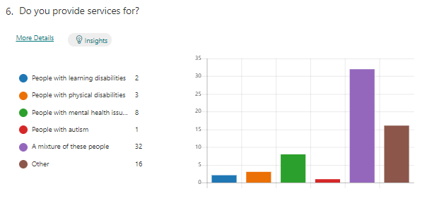
Question 7 - Please describe the services you provide for these target groups
A number of groups stated their services were open to all people but they did but not specifically target people with disabilities, mental health issues or autism. Services were extensive and listed below; they ranged from cultural, sports activities to day services, women only services, support for women who experienced abuse, people seeking asylum to services for people who had sight impairment, people with mental health issues related to drug and alcohol issues. There were a small minority of groups supporting people with autism.
- Safe space, outreach crisis support, welfare checks, counselling, peer support
- Therapeutic, free boat trips to groups of disabled & disadvantaged individual
- Support people seeking asylum in Kirklees with legal and welfare support
- Offer ongoing support for children and families who life limiting conditions
- Accommodation based day services for people identified and referred through MENCAP
- In Ravensthorpe, culturally sensitive day services for people with learning disabilities for 20. ESOL classes provide low level mental health support. User groups use facilities and provide mental health support
- In Savile Town - 1) Bismillah Association - Men’s session each week sessions – social activities to keep people busy and address mental health. 2) Savile Town Women’s Association provided a weekly service before the pandemic
- Services for people depending impacted or at risk of HIV, or are from most at risk populations. LGBT youth provision. Advocacy and 1 to 1 support. social activities
- Service for adults with Learning Disabilities - training and an easy read checking service
- Support people with mental health issues
- Support for people with learning disabilities, Council commissions specialist services for their customers. Support for people with mental health issues as Part of Kirklees Better Outcomes Partnership
- Support for people with physical disabilities including IT sessions
- Recreational, social and therapeutic services based around equine activities
- Support for people with mental health issues, around IT & self confidence courses especially with mental health, alcohol and drugs abuse
- Training for people with disabilities who want to become actors
- Sessions so that people can build up their skills, strength and confidence so they can then come out on longer rambles/rides.
- Provide housing and accommodation, group work around fishing and cooking, benefits advice, referrals to other agencies
- For people with mental health issues, course on Coping with Anxiety. Befriending services, sessions can be adapted to people with disabilities, mental health, autism
- Would like to develop provision to address the mental wellbeing and resilience young people, interested in incorporating mindfulness, yoga and other simple practices
- A range of personalised arts and crafts activities and social opportunities to all involved
- Volunteering Opportunities – including manning food banks on Huddersfield Town match days. Premier League Kicks Disability Sessions – delivered weekly, football and workshop sessions specifically for disabled participants. Weekly Mental Health Football
- Helpline ISVA Therapy and emotional support psycho-educational. Group work training
- Community regeneration, activities and courses, manage buildings, support new businesses and deliver affordable childcare. Bee 2gether Group offer activities around Growing and Sewing– not targeted but people with disabilities and mental health issues have attended
- Activities for people who have sight loss they are here to help and that includes people with physical, disabilities, mental health and autism Peer support, run by blind people. Teaching technology to enhance independence. Run projects around training employment
- Counselling
- Create project includes family support where children may have autism and included Cygnet Parent support for parents and carers of child with autism
- For people with physical disabilities provide cleaning, shopping, hot meals, befriending, luncheon club. People with mental health issues •Weekly Connect group for over 50’s via zoom to combat isolation and loneliness •Women2women group to provide an outlet for women to express themselves and reflect
- IAPT (Improving access to psychological therapies) Couple therapy for depression. All counselling available to target groups in this mapping exercise, but they would need to have capacity and give consent
- For people with learning and physical disabilities World Dance sessions delivered at Waves Daycare in Slaithwaite. People with physical disabilities - sessions at care homes for seated dance and instrument playing. People with mental health issues –world dance sessions at Kirklees recovery College and Support to Recovery in Huddersfield
- S2R welcomes all individuals including those with any issue/disability where ever possible. Creative and social group for people diagnosed with neurodivergent issues and specialist phone support during the Covid lockdown. Where possible, projects and activities are in fully accessible venues, outdoor projects are assessed and where possible and funding permitted adapted for wheelchair access etc. Undertake Autism environmental risk assessments but as service is based on creativity, specialist support is dependent on funding.
- Support people who have experienced baby loss or separation, trauma informed therapy - post traumatic stress disorders faces 50% of clients
- Through holistic support to women who have experienced domestic abuse, support is available to people with physical disabilities Support. Each refuge has a unit in each refuge, which is accessible with wet rooms. May have arthritis, bone issues not diagnosed. Many have mental health and this is reviewed as part of needs assessment, look at mental health, other health issues, including physical additional learning needs. Under new DA Bill, LA has duty of care to children in refuge. No funding for mental health support but they need this service then and there, they move all the time so therapy is delayed for 6 months.
- Arts and crafts for people with mental health issues on a weekly basis
- Yoga sessions
- Anchor organization which supports all members of the community, including people with learning disabilities. Provide various care services to people with physical disabilities, mental health issues. Arranged housing for one person with learning difficulties and for an elderly person who was not able to walk far. Have arranged shared housing for a person who was isolated. Hold weekly Wednesday afternoon sessions for chat, physical activities
- Work based activities, crafts and horticulture

Question 8 - How many people do you support
It is worth noting that some groups gave the number of users for the previous year and some for the present day. Some organisations gave overall numbers of users as their services were not targeted at specific groups, but open to anybody. Those groups with a wide reach and with a higher than normal online presence during the lockdown period, reported the highest numbers.
The range of users was from just 8 people receiving intensive support to 3000 on line participants annually. The average number per year was approximately 200.

Question 9 – Which age groups do you work with?
Many groups provided services for a mixture of ages. Where 28 groups stated other, this included specifying the age of the majority of their users; for example, ‘over 55’ or ‘over 70’.

No services focused solely on children or solely on adolescents, rather as detailed in the surveys, they stated services were for people aged ‘7+’ or ‘13+’, for example.
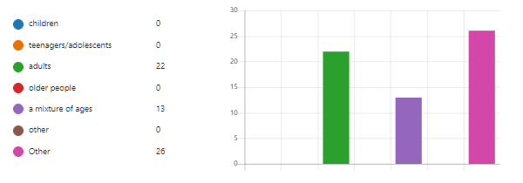

Questions 10 - To which ethnic groups to your users belong or provide an approximate percentage split of ethnicity?
71% reported that their provision was open to all sections of the community
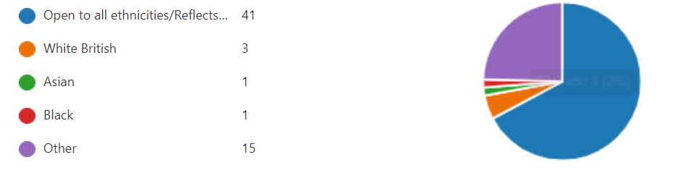

Question 11 - In which areas of Kirklees do you provide services?
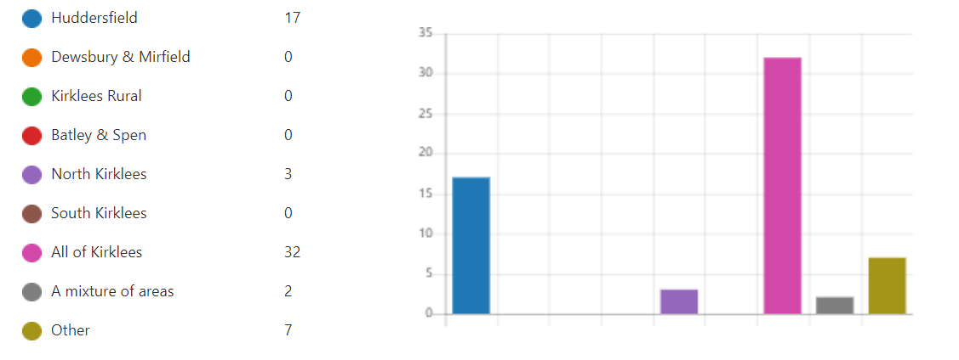

Question 12 - Do you believe your organisation is financially sustainable?
The majority of groups stated they were
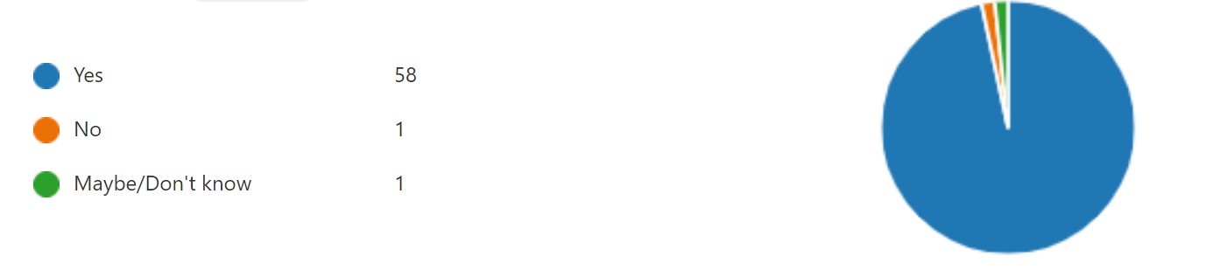

Question 13 - Have you encountered any recent loss of income?
Over half the groups had lost income, through lost revenue from room bookings, wedding hire, lost income from activities eg yoga, training, childcare
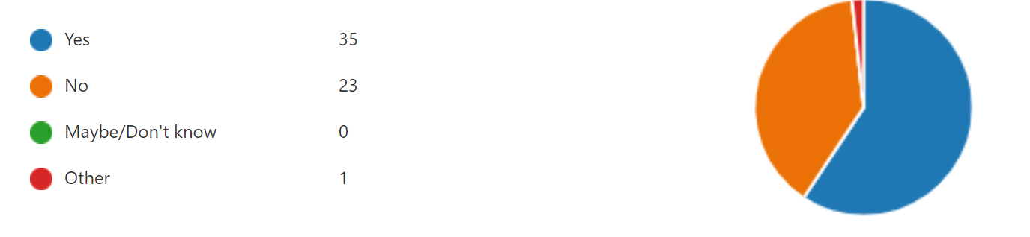

Question 14 - What support would help your organisation to sustain its services?
33% of respondents answered ‘Funding’ to this question. However many wanted support to develop and promote their core business, link with other groups, connect with other services and good relationships with other VCS groups and commissioners. Others area of supported required were around:
Help recruiting and supporting volunteers
Need help with a good business plan
Tie in more with social prescribing, help to raise awareness of their organisation; would like an event to showcase their work, contact with other occupational therapists and health services
Parity of esteem between public sector and VCS
Access to free training outside normal working hours
Organisations and funders to have meaningful strategies for voluntary sector inclusion
Organisations and funding bodies have community and volunteer champions
Becoming an independent group
Continued longer term contracts and sustained support with Council and health authorities
Help to increase the number groups they provide to deliver more services/activities
Help with IT and social media
Financial support to continue befriending services post Covid
Advice or provision of mental health expertise to support the group’s work
Training for staff on finding legacy funding
Help to manage web site, write a marketing plan and help to embed learning after training
Low cost ethnical loans to help centres develop new business
Use of free rooms
Help on evaluation of the impact of the group’s work
Paid referrals from NHS and Council, being commissioned and services recognising group’s worth
Support to hire tracks and maintenance of bikes
Low cost childcare, so parents can seek employment and training, help to run food club
Specialist support for women and children complex needs, mental health and trauma, recovery work
More access to Thornton Lodge Community Centre, managed by Kirklees
Therapeutic group work for yoga to address to mental health, not everyone wants talking therapy
Help to promote their rooms for hire

Question 15 - Do you use digital technology to engage with services users?
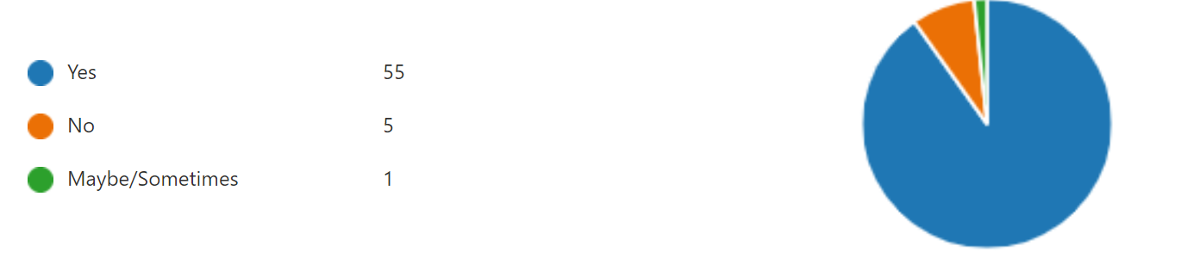

If you do not use digital technology, please outline the reasons why
The group which answered ‘other’ reason was referring to the fact it was not appropriate as their organisation provided outdoors equine therapeutic services.
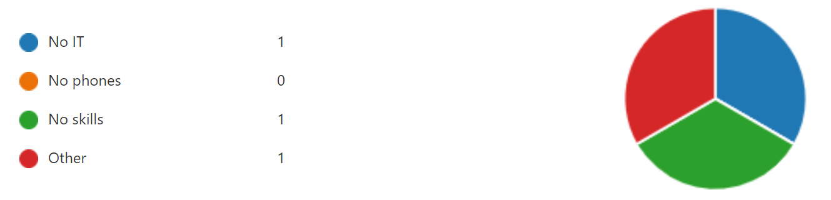

Question 16 - Are you already aware of SWYFT or work with the trust?
Many knew of the existence of the Trust but not many had worked with it.
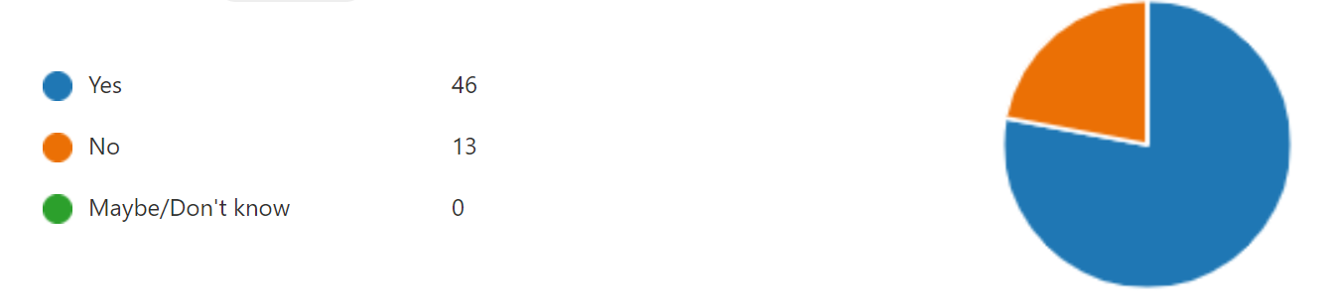

Question 17 - Can we share your details with SWYFT?
Sixty two replied yes and 1 organisation, no

Question 18 – What is the best way for us/ SWYFT to communicate with you and local groups
This question and question 19, were added after SWYFT highlighted at a June meeting that they would be interested to establish the best means of engaging the VCS and therefore the responses are quite low as only half the interviews posted these questions.
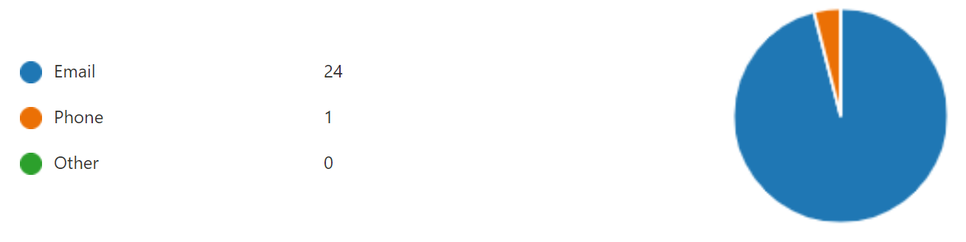

Question 19 – How should SWYFT keep groups updated about their work and opportunities to collaborate?
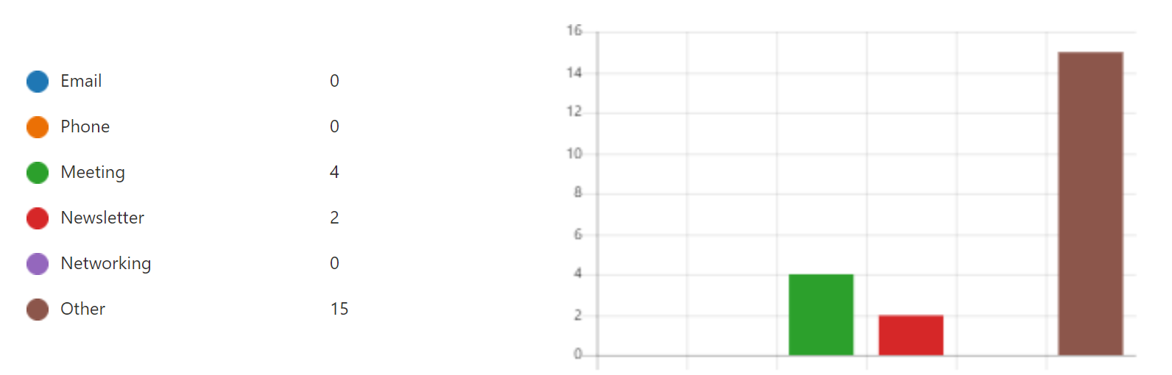
Other comments included:
Networking events with loose agenda to allow free dialogue
Visits to groups
Organise meeting to discuss mental health issues, with other providers and commissioners
Like Kirklees, send application forms to groups for SWYFT grants
New community directory
Facebook

Question 20 - Are you aware of Third Sector Leaders (TSL)
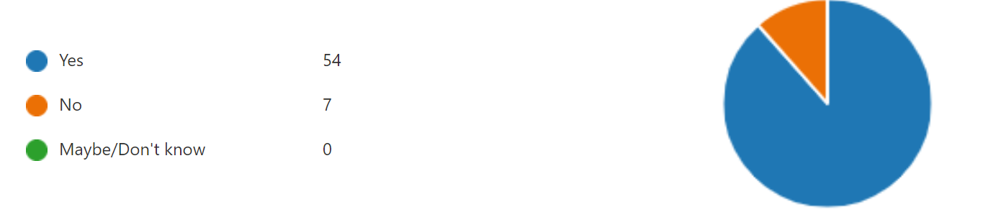

Question 21 - What TSL activities are you engaged with?
Of the organisations which responded, the majority were involved with a mixture of activities
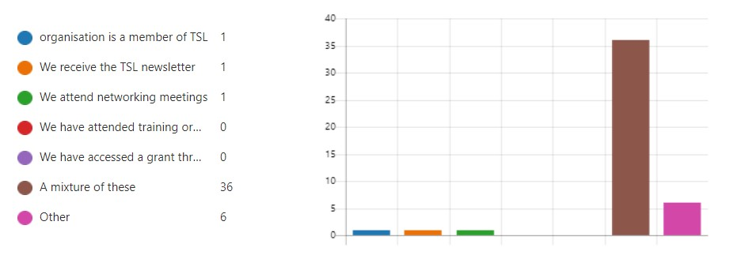

Question 22 - What additional support would you like from TSL?
Groups were very positive about the support TSL provides and comments included:
“TSL are already very helpful”
“If we need anything, TSL are always the main port call”
“Nothing more, TSL do a fantastic job and the staff are great!”
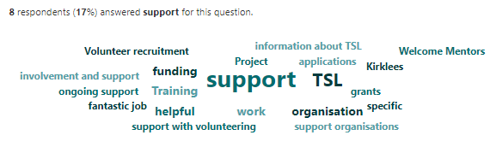
Additional support required included:
Training for staff, volunteers, trustees
More campaigning on behalf of VCS as it is anonymous – groups do not to jeopardise commissioning
Some groups need mentoring on how to run the group, may be a buddying system between groups
Training on how to take minutes, chair, and roles of members
IT support and Project Management Software
Volunteer recruitment for youth work
Specific business plan, marketing training and ongoing support to implement these
Advice on tender opportunities and specific words to use when searching for opportunities
Help with recruitment
Help to promote group’s work
Training around grant application, biding for contracts and partnership working,
More clarity on TSL does clarification about Welcome Mentors project
Advice on transport for disabled members to get to meetings
Bring people in VCS sector together face to face an annual event
More promotion of new funding streams to VCS
When gaps in services are identified by commissioners, contact groups to check if they can respond
Template policy documents
Help promoting rooms and community resources

Question 23 - Do you have any other comments about this mapping exercise?
“Mental health issues can be grounds for an asylum claim (under the human rights route) so we definitely need good working links with organisations who have specialisms as this could directly impact outcomes, positively”
“There will be key information collated as part of this mapping; it will help to improve learning and understanding of capacity skills of VCS and challenges”
“Good exercise.”
“Mental health is a big issue, highlighted more because of COVID, in Asian community still that taboo. A lot of young people affected now who were not previously there has been a lot of change for them. In school and university.”
“There will be a group set up to run a council building (in Almondbury), there will be some mental health services and we would like to know so we can publicise the services once they are up and running, should we contact SWYFT or TSL?”
“Really interested in the outcomes and happy to come and do a presentation to anybody about services we provide and keen to promote these.”
"No questions on sexual orientation or gender and gender identity which is a bit of concern given what is being mapped.”
“Perhaps those commissioning research/mapping consider incentives to the sector to participate – in recognition of time spent and to support the VCS. Even a token payment, £30 - £50 could be a massive help to those unfunded organisations which are voluntary led.”
“I would be really interested in engaging with groups to talk about Kirklees approach to sexual violence”
“This mapping will be out of date quickly. Less a mapping, more a snapshot!”
“Good that people are interested in our views – very interested in hearing about commissioning opportunities.”
“Anything like this exercise is great because people are coming together it improves joined up working”
"Really hard to keep on top of who is out there and a directory of services and keep on top of this and current, a joint website maybe.”
"Like to know if the SWYFT put out opportunities for commissioning or large contracts £10K to £25k , which portals do they advertise on”
“We would like to know does the Trust link into to CCGs and if so what way, that needs clarifying those relationships are important and how community groups can work together to eradicate health inequalities."
“This mapping should be shared with the Council”
“We are keen to access the grant aid through this project”
“Good that there is recognition of the big role VCS play to support the target disadvantaged groups”

